Gokul Natesan
Algorithms
1/25/15

Project 1 Report

1. The implementation of my nearest neighbor approach is fairly simple. I put all the points from the text file into an array list. Therefore, the first point in the text file was the first element of the array list, so it was my initial point. In the pseudo-code, it says while there are still unvisited points, select the point that is closest to the unvisited point and use that as your next base point. I efficiently implemented this statement through the use of a nested for loop. The outer for loop starts at the beginning of the list(value i), and goes up to the second to last value in the list, and the inner for loop starts at i + 1, and goes up to the last value of the array list. Basically, my inner loop goes through all the values after index i, searching for the closest neighbor to the value at i. It then swaps the value of the nearest neighbor to i, with the value at index i+1. After that, the outer loop increments by 1, and the process repeats. In the meanwhile, there is a distance variable that is calculating the total distance and adds up the distances between points. After the loop is done, the array list will be sorted by the order in which the points are visited. Finally, I add the distance between the last value and the first value in the array list to make sure I account the distance of going back to the starting point. This is indicated in the pseudo-code where it says return to p₀ from p_{n-1}.

The exhaustive search required a bit more work and was not as simple. I first created a permute method which takes in an array list of points and returns all the possible permutations of the list in an array list containing an array list of points. Then, I made a method called indexOfBestArrangement. This method calls the permute method on the list of points, and then loops through the returned array list, and calculates the distance traveled for each permutation of points. Once the function calculates the minimum distance traveled, it stores this value into a variable and returns the index of where this array list of points was found in the bigger array list. I call this method and then I can print out the point values of the best possible traversal and its distance traveled.

2. Nearest-Neighbor:
For a list of size n, I start at index 0 and look at the distance between the rest of the values and the value at index 0, swapping the value at index i + 1 with the value of the shortest distance. I used a nested for loop to do this, which results in a big-O notation of O(n²). By looking at my code, I can determine this when I examine the number of lines outside of both loops, inside the outer loop, and inside both loops. Doing this, I get O(3n²+6n+3) which is O(n²).

Exhaustive Search:
The permutation function in the exhaustive function has a complexity of O(n!). This is because the function takes a list of all the points in the text file, and it then makes a list for each unique possible combination. Therefore, there are n! combinations of the list with size n. Then, I go through a double for loop which helps me find the index of the best possible list. This takes a complexity of n², which has a smaller complexity than n!. Therefore the complexity for the exhaustive search is O(n!).

3.
Search Type (n) | Trial 1 (s) | Trial 2 (s) | Trial 3 (s) | Average Time (s)
Nearest Neighbor (5000) | 2.295 | 2.291 | 2.271 | 2.285
Nearest Neighbor (6000) | 3.256 | 3.297 | 3.278 | 3.277
Nearest Neighbor (10000) | 9.024 | 9.057 | 9.023 | 9.034
Nearest Neighbor (20000) | 36.02 | 36.05 | 35.90 | 35.99
Exhaustive (7) | 0.0166 | 0.0171 | 0.0178 | 0.0172
Exhaustive (8) | 0.0488 | 0.0443 | 0.0434 | 0.0455
Exhaustive (9) | 0.144 | 0.332 | 0.147 | 0.208
Exhaustive (10) | 5.11 | 6.22 | 6.29 | 5.87

I chose extremely large values for the nearest neighbor search, because the algorithm runs really fast so having small values would result in extremely small run times. Additionally, since it has a complexity of n², it does not grow in a high speed manner, so I decided to make my values of n spread out in order to see the time change.

I chose smaller values for n in the exhaustive search, because it uses a lot of memory, so having a large value for n would give an out of memory error. This is due to the simple fact that the exhaustive implementation creates the every single permutation of the list. Also, I chose values that were close together, because since algorithm has a complexity of n!, it will eventually experience very sharp jumps in output for small changes in the input.

4. Nearest-Neighbor Search:
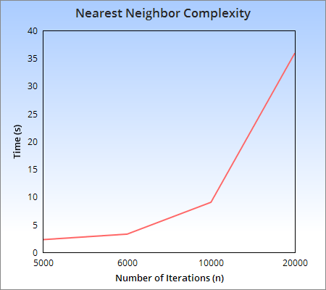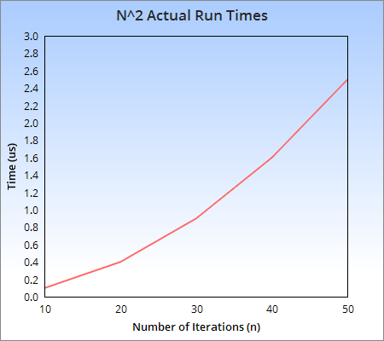

When graphing my experimental runtimes, the curve generated is very similar to that of the theoretical complexity of n². This shows that my experimental runtimes are consistent with the theoretical complexities I derived. We are not really paying attention to the x and y values, but rather how the curve grows.

Exhaustive Search:
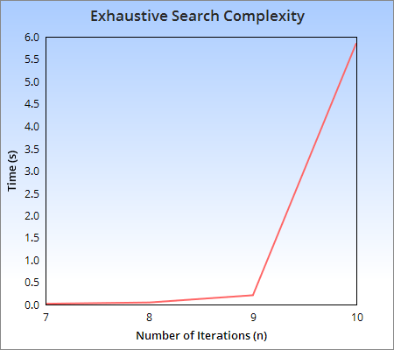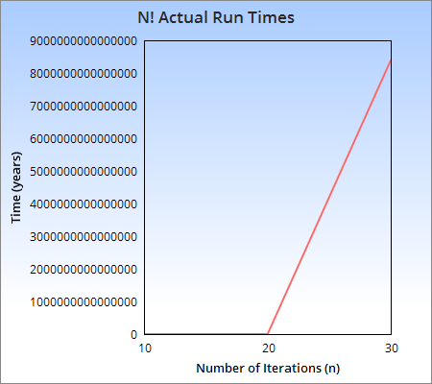

Like the Nearest-Neighbor Search, when I graph my experimental data, the curve is very similar to that of the actual run times for n!. This indicates that my experimental runtimes are consistent with that of the theoretical complexity derived. Once again, the most important component when analyzing these graphs is how the curve grows.

